Quiz Application using tkinter

I created a class named ‘Quiz_Gui’ with all necessary functions in it. A text file to store all the question, options and their answers using a strict format of input. A python class ‘Questions’ in ReadQuestion.py to fetch the questions, options and answers from the text file and store it in a dictionary variable.

The questions, options and answers are stored in a text file in a particular format as given below.

<Question>_<Option1>_<Option2>_<Option3>_<Option4>_<Answer Number (1,2,3,4)>

Example:

What is value of 2+2? _3_4_5_6_2

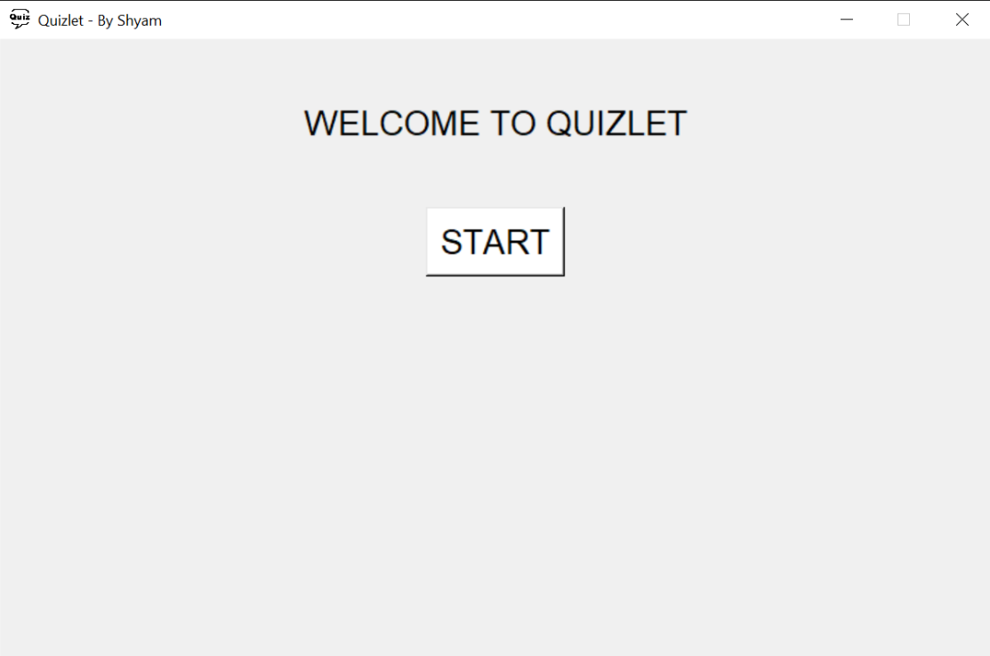The main window is ‘window’ with a geometry of 800x500. The very first screen is the welcome screen with a start button to begin the quiz whenever player is ready.

On clicking the start button the welcome frame is destroyed and two other frames are displayed namely ‘questionFrame’ & ‘questionPanelFrame’.

1. **questionPanelFrame:**

* It is the frame on the leftmost side of main window. It contains the listbox of all 10 questions. Clicking on each question will display the question and options on another questionFrame.

1. **questionFrame:**

* It is the frame on the right side of the main window. It contains six elements:
  1. Question Label: To display the question.
  2. 4 Radio Buttons for all four options.
  3. A submit button to submit the answers.
* 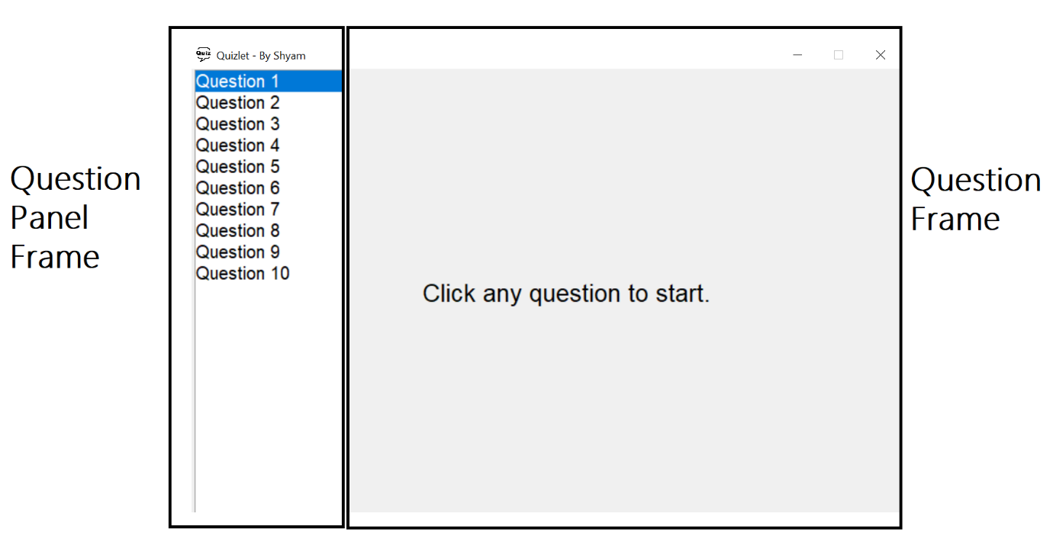User can start by clicking on any question number. After the question number is clicked it will display the question the options and a submit button.

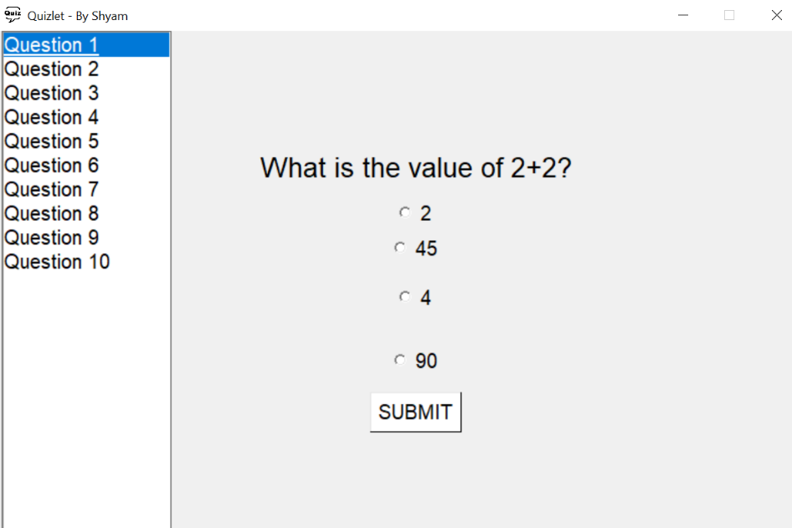

* Selecting the option will change its color to “Green” and will show green whenever user switches back to the same question.

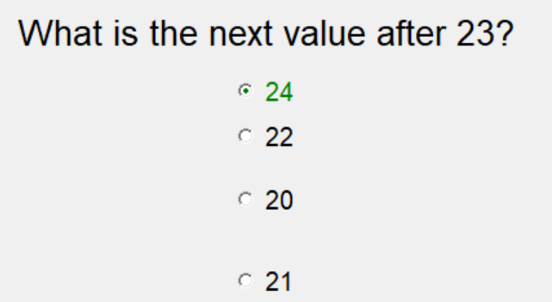

* If the user submits before answering all the 10 questions, a message box will pop up giving information of how many questions have been attempted and is user sure to submit the answers. If selected “YES” it will print the score or else the quiz will continue.

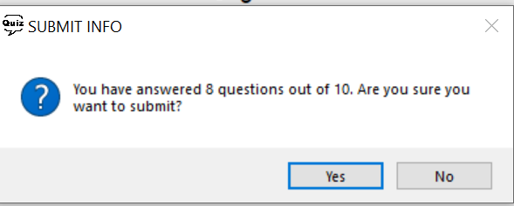

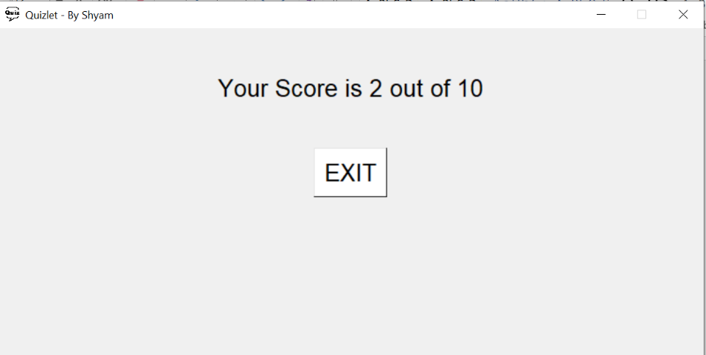

* Finally, after submission it will destroy both frames ‘questionFrame’ and ‘questionPanelFrame’ and will display the score on the window with an exit button to exit the app.